

**Deakin College**

**FNDB020 Accounting**

**Student Workbook**

**Lecture and Tutorial**

**Week 1**

**Updated February 2018**

**Accounting Terms**

Check your understanding of these terms which you will learn about in this week’s lecture and tutorial. There is space to add your own new words to the list.

* You could use **Quizlet** to do this task on your laptop. Link <https://quizlet.com/join/DKC7gUy4F>. Some definitions are already completed for you. Need to register on Quizlet.com



|  |  |
| --- | --- |
| **Term** | **Meaning** |
| Cash at bank |  |
|  |  |
| Transaction |  |
|  |  |
| Liabilities |  |
|  |  |
| Assets |  |
|  |  |
| Equity |  |
|  |  |
| Capital (Contribution) |  |
|  |  |
| Drawings |  |
|  |  |
| Financial statements |  |
|  |  |
| Accounts payable |  |
|  |  |
| Accounts receivable |  |
|  |  |
| Loan |  |
|  |  |
| Funds |  |
|  |  |
|  |  |
|  |  |
|  |  |
|  |  |
|  |  |

**FNDB020 Lecture Week 1 Accounting for Decision Making**

Aim of this lesson

|  |
| --- |
| 1. What is Accounting |
| 1. Who uses accounting information |
| 1. Financial Accounting and Management |
| 1. Accounting |
| 1. The Accounting Equation |
| 1. Financial Statements |

## Role of Accounting

## Users of Accounting Information (slide 5)

1. Internal users:
2. Identify Possible information required
3. External users are
4. Identify possible information they may need
5. Two Types of Accounting are**:** (slide 7)

**International Financial Reporting Standards (IFRS)**

In Australia, the Australian Accounting Standards Board (AASB) is a government appointed independent accounting body that is responsible for developing accounting standards. The AASB is gradually adopting the International Financial Reporting Standards (IFRS). The IFRS are a set of guidelines that help preparers of financial statements decide how and what financial information is reported by businesses. The set of financial statements are called the General Purpose Financial Statements (GPFS).

This course focuses only on Financial Accounting and General Purpose Financial Statements (GPFS).

## Ethics and Accounting

Class discussion

# Ch2 Financial Statements

The following section is based on Hoggett Ch 2

## Types of business entities

1. Sole owner
2. Partnership
3. Company

## Accounting elements - brief

## Case Study: *Adele’s Garden Design* business

**Lists items (assets) Adele will need to start her business**

|  |  |
| --- | --- |
| Item | Approximate cost |
|  |  |
|  |  |
|  |  |
|  |  |
|  |  |
|  |  |
|  |  |
| Total Value of Items |  |

## Key Question: How can Adele fund her assets?

**Suggest ways Adele can obtain the money to purchase (or lease) the assets identified above.**



## Key definitions Slide 17:

**Assets** are resources ***controlled*** by the business. They provide ***future economic benefit.***

Typical assets include:



**Liabilities** are ***obligations*** (amounts owing) of abusiness to ***transfer assets (cash)*** or ***provide services*** to another entity. Liabilities are ‘claims by outsiders’.



**Equity ( or Owners Equity)** represents the business owner’s wealth orinterest in the business. Equity also reflects the rights of owners on the business assets**.**



All business like Adele’s will normally use a combination of Equity and liabilities to fund their assets and initial start up costs.

## Accounting Equation: A = L + E Balancing the Equation

1. **Required:**

Adele decides to explore different ways of funding her start up business. Below are the possible capital (owner’s contribution) scenarios if she decides to fund the business assets from her own savings.

|  |  |  |  |  |  |  |  |  |  |  |  |  |  |  |  |
| --- | --- | --- | --- | --- | --- | --- | --- | --- | --- | --- | --- | --- | --- | --- | --- |
| |  |  |  |  |  | | --- | --- | --- | --- | --- | | **ASSETS** | **=** | **LIABILTIES** | **+** | **EQUITY** | |  | **=** | **NIL** | **+** | **50,000** | |  | **=** | **NIL** | **+** | **25,000** | |

1. Do you see any limitations to owner’s contribution if Adele needs to buy more business assets?
2. Do you see any benefit(s) to owner’s contribution if Adele is successful with her small business operations and makes profits without borrowing from lenders (outside parties)?
3. **Required:**

Adele now decides to take a loan and purchase goods on trade credit. Below are the possible scenarios if she has budgeted $120,000 for the business assets:

|  |  |  |  |  |  |
| --- | --- | --- | --- | --- | --- |
| **Scenario** | **ASSETS** | **-** | **LIABILTIES** | **=** | **EQUITY** |
|  |  |  | **(borrow from lender)** |  | **(invest as owner)** |
| **1** | **120,000** | **-** |  | **=** | **70,000** |
| **2** | **120,000** | **-** |  | **=** | **45,000** |
| **3** | **120,000** | **-** |  | **=** | **25,000** |
| **4** | **120,000** | **-** |  | **=** | **5,000** |

Do you see any change to Adele’s control over the business assets as her borrowing increases? Rearrange the equation to A – L = E represents her net claim over the business assets after paying off liabilities:

Answer:

## How Operating Income & Expenses affect Equity

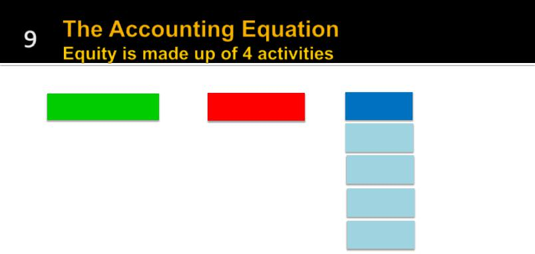

|  |  |  |  |  |  |  |
| --- | --- | --- | --- | --- | --- | --- |
| ASSETS | = | LIABILITIES | + | EQUITY |  |  |
|  |  |  |  |  |  |  |
|  |  |  |  | Capital | improves equity |  |
|  |  |  |  |  |  |  |
|  |  |  |  |  |  |  |
|  |  |  |  | Drawings | reduce equity |  |
|  |  |  |  |  |  |  |
|  |  |  |  |  |  |  |
|  |  |  |  | Income | improves equity |  |
|  |  |  |  |  |  |
|  |  |  |  |  |  |  |
|  |  |  |  | Expenses | reduce equity |  |
|  |  |  |  |  |  |
|  |  |  |  |  | navitas.com |  |
|  |  |  |  |  |

**Question** If the business owner puts (invests) money into the business, is this income? Yes or No

**Question**

Adele, as the business owner, may also decide to withdraw (take out) assets from the business entity. The withdrawal of assets can be in the form of cash, equipment (like a laptop or used car). These ‘Drawings’ will ***reduce*** the equity in the business.

Can you think of some reasons why Adele would want to withdraw assets from the business?

|  |
| --- |
|  |
|  |
|  |
|  |

## Business operations: Income and expenses

**Income** is earned as Adele sells design plans to clients.

**Expenses** (costs related to running a business) like purchasing design supplies, paying for electricity and telephone charges will be incurred. The result of income and expenses is called the ***financial performance***.

Where income exceeds expenses an **operating profit** is made. If income is less than expenses, an **operating loss** is made.

**Required:** (choose the most appropriate response)

1. **Income** improves **OR** reduces the Adele’s wealth in the business, increasing equity.
2. **Expenses** are costs that improve **OR** reduce Adele’s wealth in the business thus decreasing equity
3. List 5 typical expenses in Adele’s design business

## Classifying Accounting Elements

Classify the following items of J Jones Accounting Services into Assets (A), Liabilities (L) Equity (OE) Income (I) or Expenses (E) at 30/6/201X

|  |  |  |  |  |  |  |
| --- | --- | --- | --- | --- | --- | --- |
|  |  | Income Statement | |  | Balance Sheet | |
|  |  |  |  | A | = L | + Equity |
| Items | $ | Income | Expenses | Assets | Liabilities | Equity |
| Cash at bank | 33,500 |  |  |  |  |  |
| Mortgage loan | 75,000 |  |  |  |  |  |
| Accounts receivable | 23,000 |  |  |  |  |  |
| Accounts payable | 14,000 |  |  |  |  |  |
| Drawings | 4,200 |  |  |  |  |  |
| Supplies | 2,000 |  |  |  |  |  |
| Telephone payable | 450 |  |  |  |  |  |
| Computer | 3,600 |  |  |  |  |  |
| Equipment | 45,000 |  |  |  |  |  |
| Building | 120,000 |  |  |  |  |  |
| Rent expense | 1,000 |  |  |  |  | Equity reduces |
| Wages expense | 5,600 |  |  |  |  | Equity reduces |
| Wages payable | 2,610 |  |  |  |  |  |
| Capital – J Jones opening amount | 101,850 |  |  |  |  |  |
|  |  |  |  |  |  |  |
| Telephone expense | 650 |  |  |  |  | Equity reduces |
| Service fee income | 45,700 |  |  |  |  | Equity improves |
| Interest income | 290 |  |  |  |  | Equity improves |
| Advertising expense | 1,350 |  |  |  |  | Equity reduces |

## Linking the Financial Statements

|  |  |  |  |  |  |  |  |  |  |  |  |  |  |  |  |
| --- | --- | --- | --- | --- | --- | --- | --- | --- | --- | --- | --- | --- | --- | --- | --- |
|  |  |  |  |  |  |  |  |  |  |  |  |  |  |  |  |
|  |  |  |  |  |  |  |  |  |  |  |  |  |  |  |  |
|  |  |  | = |  |  |  |  |  |  |  |  |  |  |  |  |
|  |  | ASSETS |  | LIABILITIES |  | + |  | EQUITY |  | Balance Sheet | | |  |  |
|  |  |  |  |  |  |  |  |  | Capital |  |  |  |  |  |  |
|  |  |  |  |  |  |  |  |  |  |  | Change in | |  |  |  |
|  |  |  |  |  |  |  |  |  |  |  |  |  |
|  |  |  |  |  |  |  |  |  | Drawings |  |  |  |
|  |  |  |  |  |  |  |  |  |  | Equity | |  |  |  |
|  |  |  |  |  |  |  |  |  |  |  |  |  |  |
|  |  |  |  |  |  |  |  |  |  |  |  | Statement |  |  |  |
|  |  |  |  |  | Income | |  |  | Income |  |  |  |  |  |
|  |  |  |  |  |  |  |  |  |  |  |  |  |
|  |  |  |  |  |  |  |  |  |  |  |  |  |  |
|  |  |  |  |  |  |  |  |  |  |  |  |  |  |
|  |  |  |  |  | Statement | |  |  | Expenses |  |  |  |  |  |  |
|  |  |  |  |  |  |  |  |  |  |  |  |  |  |  |  |
|  |  |  |  |  |  |  |  |  |  |  |  |  |  |  |  |

General purpose financial statements (GPFS) include the:

* Income statement (a report on the business operations or ***financial performance***) Income less expense;
* Balance Sheet (a report on the ***financial position*** or A = L+ OE);
* Statement to Changes in Equity (identifies how equity has improved or reduced);

**Sample Balance Sheet (Source: HEM 9E, p 39)**

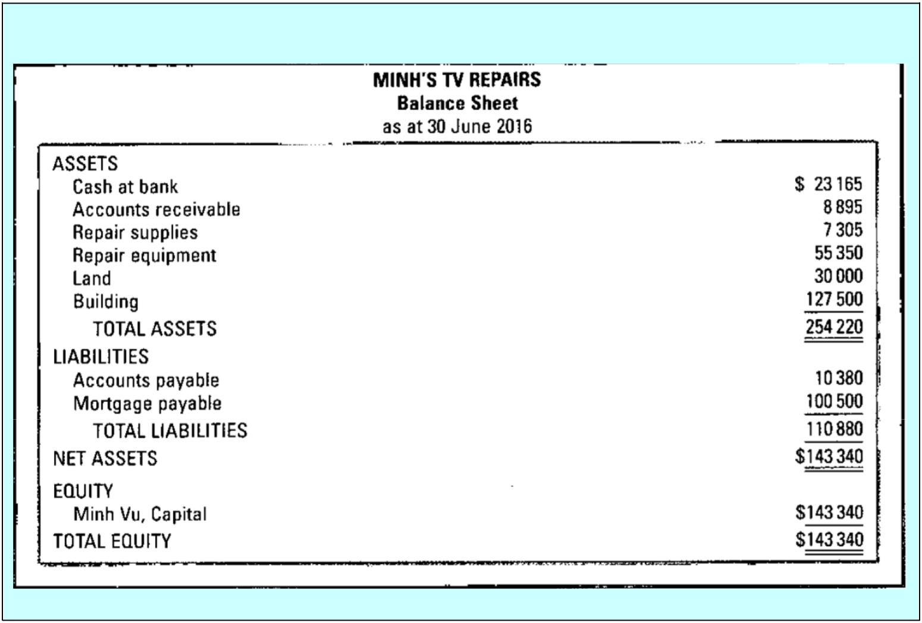

**Sample Income Statement (Source: HEM 9E, p 40)**

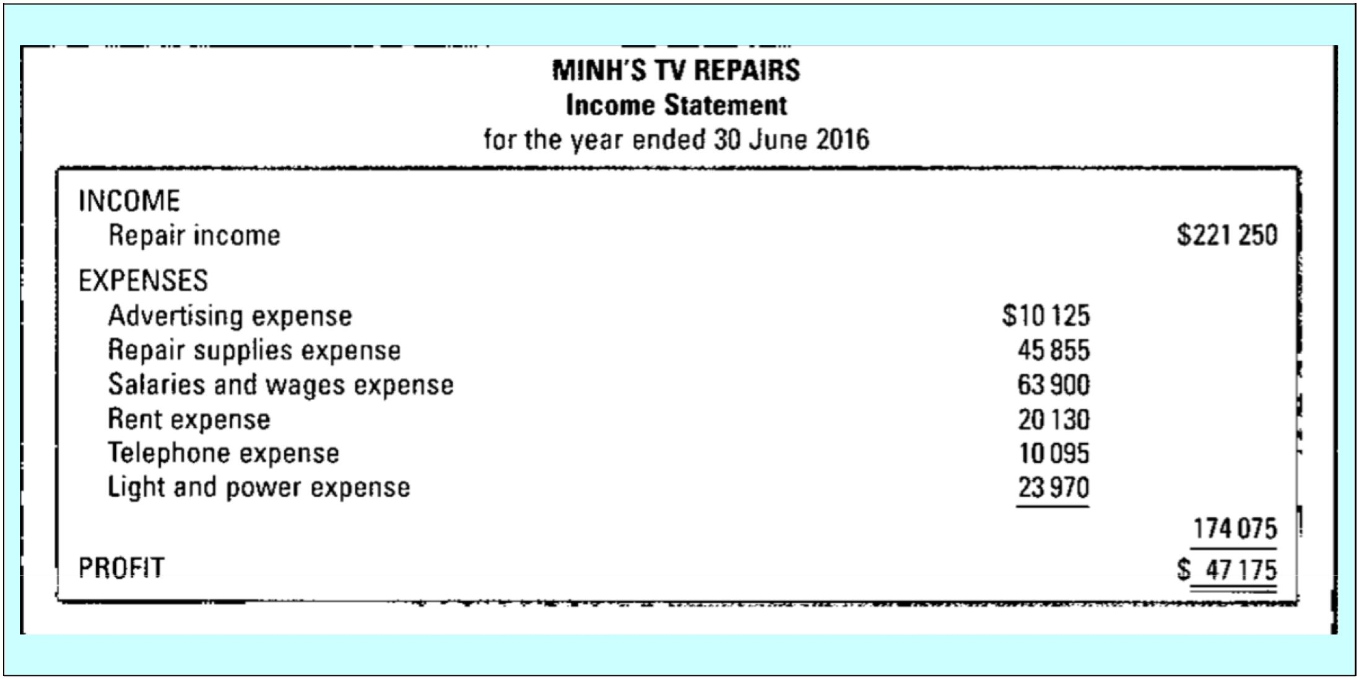

**Sample Statement of Changes in Equity (Source: HEM 9E, p 41)**

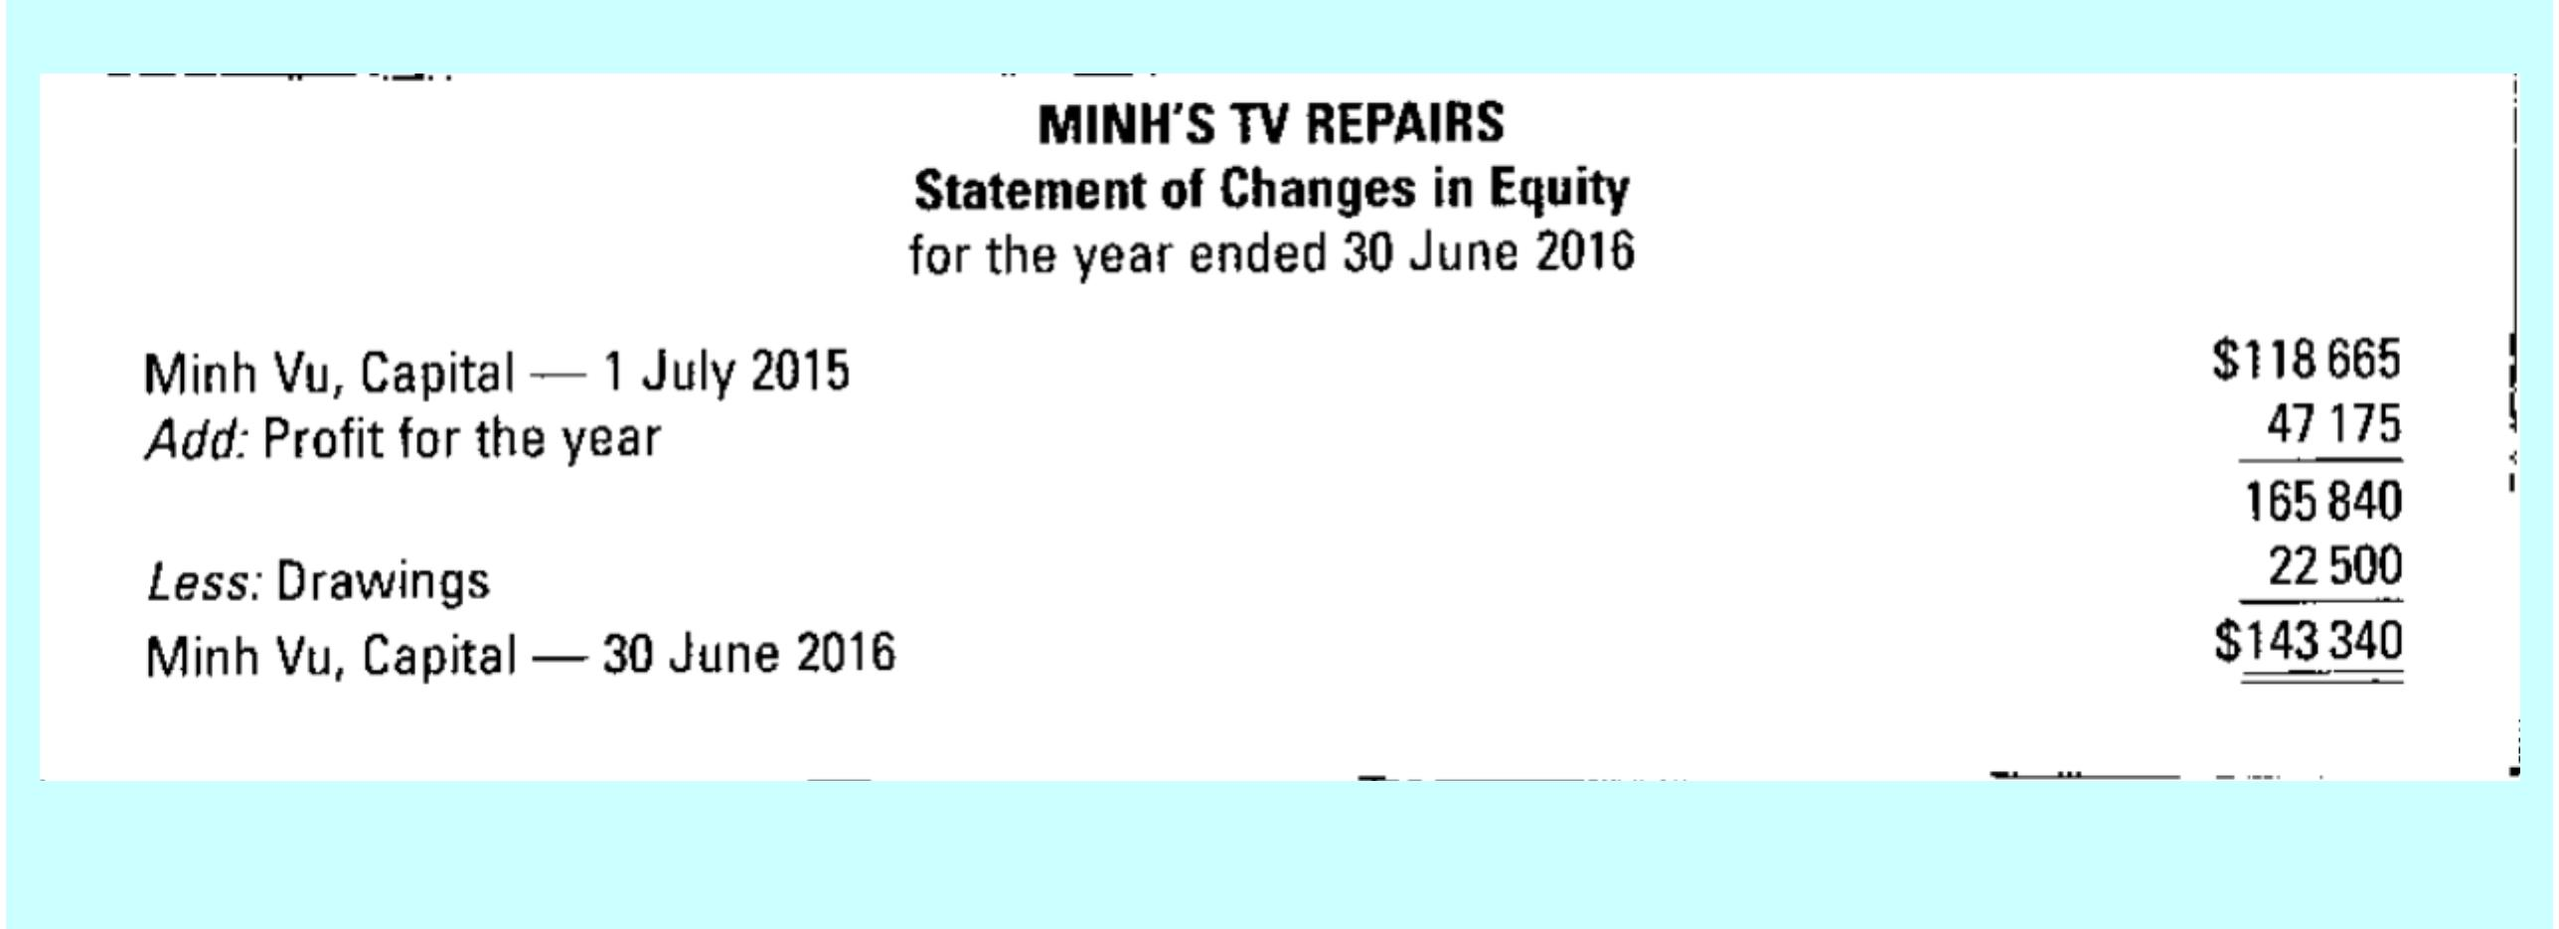

## Use the information in Task 14 to prepare Accounting Reports

|  |  |  |  |
| --- | --- | --- | --- |
| Income statement for J Jones  for the year ending 30/6/2018 | | | |
|  |  |  |  |
| Service Fees |  |  |  |
| interest income |  |  | 0 |
| **less Expenses** |  |  |  |
| Rent expense |  |  |  |
| Advertising expense |  |  |  |
| Wages |  |  |  |
| telephone expense |  |  | 0 |
| = Profit |  |  | 0 |

|  |  |  |  |  |  |
| --- | --- | --- | --- | --- | --- |
| Balance sheet at 30/6/2018 | | | | | |
| **Asset** |  |  | **Liabilities** |  |  |
| Cash at bank |  |  | Accs payable |  |  |
| Accs receivable |  |  | telephone payable |  |  |
| supplies |  |  | wages payable |  |  |
| computer |  |  | mortgage |  |  |
| equipment |  |  |  |  | 0 |
| building |  |  | **Owner’s Equity** |  |  |
|  |  |  | Capital |  |  |
|  |  |  | **less** Drawings |  | 0 |
|  |  |  | **plus** profit |  | 0 |
| Total assets | 0 |  | Total L and OE |  | 0 |
|  |  |  |  |  |  |

Solution

|  |  |  |  |  |  |  |  |  |  |  |  |
| --- | --- | --- | --- | --- | --- | --- | --- | --- | --- | --- | --- |
| Income Statement for J Jones for the year ending 30/6/2018 | | | | | | | |  | |  | |
|  | |  | |  | |  | |  | |  | |
| Service Fees | |  | | 45,700 | |  | |  | |  | |
| interest income | |  | | 290 | | 45,990 | |  | |  | |
| **less Expenses** | |  | |  | |  | |  | |  | |
| Rent exp | | 1,000 | |  | |  | |  | |  | |
| Advertising exp | | 1,350 | |  | |  | |  | |  | |
| Wages | | 5,600 | |  | |  | |  | |  | |
| telephone exp | | 650 | |  | | 8,600 | |  | |  | |
| = Profit | |  | |  | | 37,390 | |  | |  | |
|  | |  | |  | |  | |  | |  | |
| Balance sheet at 30/6/2018 | | | |  | |  | |  | |  | |
| **Asset** |  | |  | | **Liabilities** | |  | |  | |
| Cash at bank | 33,500 | |  | | Accs payable | | 14,000 | |  | |
| Accs Receivable | 23,000 | |  | | Tele payable | | 450 | |  | |
| Supplies | 2,000 | |  | | wages payable | | 2,610 | |  | |
| computer | 3,600 | |  | | mortgage | | 75,000 | |  | |
| equipment | 45,000 | |  | |  | |  | | 92,060 | |
| building | 120,000 | |  | | **Equity** | |  | |  | |
|  |  | |  | | capital | | 101,850 | |  | |
|  |  | |  | | **less** drawings | | 4,200 | | 97,650 | |
|  |  | |  | | **plus** profit | |  | | 37,390 | |
| Total Assets | 227,100 | |  | | Liab & Equity | |  | | 227,100 | |
|  |  | |  | |  | |  | |  | |

NB Statement of Equity is not done in this example. It is included in the Equity section of the Balance sheet.

**Linking the Financial Statements**

|  |  |  |  |  |  |  |  |  |
| --- | --- | --- | --- | --- | --- | --- | --- | --- |
| The Accounting Equation  Equity is made up of 4 activities | | | | |  |  |  |  |
|  |  | = |  | + |  |  |  |  |
|  | ASSETS | LIABILITIES |  | EQUITY |  |  |
|  |  |  |  |  |  |  |  |  |
|  |  |  |  |  |  | Capital | improves equity |  |
|  |  |  |  |  |  |  |  |  |
|  |  |  |  |  |  |  |  |  |
|  |  |  |  |  |  | Drawings | reduce equity |  |
|  |  |  |  |  |  |  |  |  |
|  |  |  |  |  |  |  |  |  |
|  |  |  |  |  |  | Income | improves equity |  |
|  |  |  |  |  |  |  |  |
|  |  |  |  |  |  |  |  |  |
|  |  |  |  |  |  |  |  |  |
|  |  |  |  |  |  | Expenses | reduce equity |  |
|  |  |  |  |  |  |  |  |

|  |  |
| --- | --- |
| **Adele’s Garden Design:** | |
| **Change in Equity = Capital – Drawings + (Income – Expense)** | |
|
|  |  | |  |

Adele has given a summary of the business operations for three months (i.e. 3 interim accounting periods):

|  |  |  |  |  |
| --- | --- | --- | --- | --- |
| Month | Income | Expense | = | Profit / Loss |
| February 2018 | $15,000 | $7,000 | = |  |
| March 2018 | $17,000 | $13,000 | = |  |
| April 2018 | $16,700 | $18,700 | = |  |



Use this information to complete the following exercises:

1. Adele decides to start her Garden Design business with a Capital of $100,000. For the first financial period the business makes a __________________**.** She decides to keep all of the profit to help her business. What is the equity in Garden Design as at the end of February?



Statement of Changes in Equity

for the month ended _______________

Opening balance:

Capital (initial investment)

Add: Profit / Loss

Less: Drawings

Closing balance

2. For the 2nd month the business makes a ___________________. Adele decides to withdraw $50,000 for her private use. What is the equity in Garden Designs as at the end of 2nd financial period?



Statement of Changes in Equity for the month ended ____________

 Opening balance (from _____________)

 Add: Profit (or less Loss)

 Less: Drawings

Closing Balance

1. For the 3rd financial period the business makes a **_________________.** Adele withdraws $20,000 for her private use. She then decided to invest $30,000. What is the equity in Garden Design as at the end of 3rd financial period?



Statement of Changes in Equity for the month ended ______________

 Opening balance (from______________)

 Add: Capital

 Add: Profit /Loss

 Less: Drawings

Closing Balance

## Understanding the accounting assumptions

1. The Entity Concept states that a business that is separate and distinct from its owners.

True / False. Explanation:

1. Wei Lin is reporting for the current accounting period of February. A client pays (cash received) $4,500 for on a 3 month service contract. Wei Lin records $4,500 as income in February. Income is correctly reported.

True/ False

Explanation:

1. Receiving a bill or being notified that an amount is owed in the current accounting period is not recorded until the amount is paid (i.e. cash is paid).

True / False. Explanation:

# Tutorial/ Homework Tasks

|  |  |  |  |  |  |  |
| --- | --- | --- | --- | --- | --- | --- |
| **Exercise 2.9** |  | **Preparation of a balance sheet** | | |  | |
|  |  |  |  |  |  |  |

Month-end balance sheet amounts for the legal practice of Adam Booth, a local lawyer, for 3 consecutive months of 2016 are shown below. The information is complete except for the balance in the Capital account.

|  |  |  |  |  |  |
| --- | --- | --- | --- | --- | --- |
|  | October |  | November |  | December |
| Cash at bank  Accounts receivable  Prepaid insurance  Office equipment  Property  Accounts payable  Wages payable  Mortgage payable  Adam Booth, Capital | $ 9 100  16 100  700  29 800  226 000  10 100  5 100  134 700  ? |  | $ 3 900  15 000  1 800  29 700  224 000  3 100  4 100  134 300  ? |  | $ 3 000  8 050  1 600  39 300  222 000  3 000  4 800  133 900  ? |

|  |  |  |  |
| --- | --- | --- | --- |
| **Exercise 2.12** |  | **Preparation of income statement and balance sheet** |  |

Toby and Talea McKellar are the joint owners of Beaut Beach Caravan Park, which is near a swimming beach popular during the summer months. The park provides not only camping facilities for caravans and tents but also up-market cabins with kitchenettes and ensuites. For the year ended 30 June 2016, Toby and Talea determined the following financial information for their business:

|  |  |  |  |  |
| --- | --- | --- | --- | --- |
| Cash on hand  Buildings purchased  Income — cabins  Salaries and wages  Supplies used  Other equipment purchased | $ 20 000  420 000  272 000  220 000  71 000  63 000 |  | Accounts payable  Accounts receivable  Income — camping  Supplies on hand  Other expenses | $ 87 000  8 000  185 000  15 000  45 000 |

A real estate agent valued the buildings at $500 000 on 30 June 2016.

**Required**

1. Prepare an income statement for Beaut Beach Caravan Park for the year ended 30 June 2016.
2. Prepare a balance sheet for the business as at 30 June 2016.

|  |  |  |  |  |  |  |
| --- | --- | --- | --- | --- | --- | --- |
| **Problem 2.2** |  | **Preparing financial statements** | | |  |  |
|  |  |  |  |  |  |  |

Asset, liability, equity, income and expense amounts for Sadoka’s Interior Decorating at 30 June 2016 are presented below:

|  |  |  |  |  |
| --- | --- | --- | --- | --- |
| Cash at bank  Accounts receivable  Supplies  Equipment  Accounts payable  Sadoka Nato, Capital  Decorating services income | $ 22 800  117 600  26 400  125 600  33 700  ?  386 000 |  | Advertising expense  Insurance expense  Rent expense  Supplies expense  Telephone expense  Electricity expense  Wages expense | $ 36 000  8 000  33 000  12 600  12 200  17 000  111 000 |

**Required**

A. Prepare an income statement for the business for the year ended 30 June 2016.

B. Prepare a balance sheet in narrative format as at 30 June 2016.

|  |  |  |  |  |
| --- | --- | --- | --- | --- |
| **Problem 2.3** |  | **Determining missing elements in accounting equation** | | |
|  |  |  |  |  |

Calculate the two missing amounts for each independent case below.

|  |  |  |  |  |  |  |
| --- | --- | --- | --- | --- | --- | --- |
| **Case** | **Total**  **Assets** | **Total liabilities** | **Total equity** | **Total income** | **Total expenses** | **Profit (loss)** |
| A | $90 000 | $37 000 |  | $76 000 |  | $24 000 |
| B | $110 000 |  | $82 000 | $45 000 | $56 000 |  |
| C |  | $18 000 | $53 000 | $80 000 |  | ($10 000) |
| D | $93 000 |  | $50 000 |  | $32 000 | ($18 000) |
| E |  | $55 000 | $120 000 |  | $60 000 | $31 000 |

Add the following items to your glossary. You could use Quizlet

https://quizlet.com/join/DKC7gUy4F

# 

**Items**  **Meaning**

Cash at bank currency and coins owned by the business. Cash can be exchanged for

another business asset or used to reduce liabilities (e.g. pay bills).

Mortgage a loan (source of funding) to the business. It is a debt that must be

repaid in the future.

Accounts receivable amounts due from customers for sale of goods or services performed on

credit. Sale to customer was on ‘sell now but collect later’.

Accounts payable amounts owed to creditors for the purchase of merchandise, supplies

and services in the normal course of business. Purchase was on ‘buy

now but pay later’.

Drawings  the withdrawal of assets from the business entity by its owner(s)

|  |  |  |
| --- | --- | --- |
|  |  |  |
| Supplies |  | Merchandise, supplies and services available for sale or use in the |
|  |  | normal course of business. Supplies are used over more than one |
|  |  | accounting period and will have future economic benefits expected to |
|  |  | flow to the entity. |
| Telephone payable |  | “payable” are purchases on ‘buy now but pay later”. This is an amount |
|  |  | that will continue to be payable (owed) until the debt is settled. |
| Prepaid rent |  | “prepaid expenses (prepayments)” or purchases of amounts that will |
|  |  | provide economic benefits for more than the *current accounting period.* |
|  |  | − e.g. prepaid for the next 6 months. |
| Equipment |  | any tools or machinery that will be used in normal course of business |
|  |  | usually for more than the *current accounting period*. |
| Building |  | an asset (e.g. factory, office building, warehouse) controlled by the |
|  |  | business as a result of past events (purchased) and from which future |
|  |  | economic benefits are expected to flow to the entity. |
| Unearned income |  | “Unearned”. The business may have received payment (cash) of |
|  |  | amounts for delivery of goods or performance of in advance but should |
|  |  | only record income when the service is provided to the client during |
|  |  | *each accounting period.* |
|  |  | − e.g. client pays for 6 months of delivery service in February |
| Rent expense |  | ‘Expense”. This is rental paid for the use of an asset business does not |
|  |  | own. Expense means that the cost is for the current accounting period. |
|  |  | − e.g. rent for the month for the use of office space; |
|  |  | − expense does not mean that it has been paid (cash); |
| Wages expense |  | ‘Expense”. This is wages to employees incurred in the current |
|  |  | accounting period. |
| Wages payable |  | “payable” is wages that is owing to employees where the business has |
|  |  | not yet paid. ‘Payable’ will remain a debt as long as it is not paid. |
| Opening Capital |  | Investment contributed by the owner into the business recorded as a |
|  |  | right of the owner over the business assets. |
| Telephone expense |  | ‘Expense”. A telephone bill for service charges for the current |
|  |  | accounting period. |
| Service income |  | “income” earned from the customer for services provided in the current |
|  |  | accounting period. |
| Interest income |  | “income” earned from business investments (other than service income) |
|  |  | in the current accounting period. |
| Advertising expense |  | ‘Expense”. Advertising charges for the current accounting period. |

**Financial Statements: Putting it all together**

**Murphy’s Law Firm for the financial year ending 30 June 2018**

(2015 S3 Lecture Week

1. Prepare an Income Statement, Balance Sheet and a Statement of Changes in Equity for Murphy’s Law Firm for the year ended 30 June 2018

|  |  |  |  |  |  |  |  |  |  |  |  |  |  |  |  |  |  |  |  |  |  |  |  |  |  |  |  |  |  |  |  |  |  |  |  |  |  |  |  |  |  |  |  |  |  |  |  |  |  |  |  |  |  |  |  |  |  |  |  |  |  |  |  |  |  |  |  |  |  |  |  |  |  |  |  |  |  |  |  |  |  |  |  |  |  |  |  |  |  |  |  |  |  |  |  |  |  |  |  |  |  |  |  |  |  |  |  |  |  |  |  |  |  |  |  |  |  |  |  |  |  |  |  |  |  |  |  |  |  |  |  |  |  |  |  |  |  |  |  |  |  |  |  |  |  |  |  |  |  |  |  |  |  |  |  |  |  |  |  |  |  |  |  |  |  |  |  |  |  |  |  |  |  |  |  |  |  |  |  |  |  |  |  |  |  |  |  |  |  |  |  |  |  |  |  |  |  |  |  |  |  |  |  |  |  |  |  |  |  |  |  |  |  |  |  |  |  |  |  |  |  |  |  |  |  |  |  |  |  |  |  |  |  |  |  |  |  |  |  |  |  |  |  |  |  |  |  |  |  |  |  |  |  |  |  |  |  |  |  |  |  |  |  |  |  |
| --- | --- | --- | --- | --- | --- | --- | --- | --- | --- | --- | --- | --- | --- | --- | --- | --- | --- | --- | --- | --- | --- | --- | --- | --- | --- | --- | --- | --- | --- | --- | --- | --- | --- | --- | --- | --- | --- | --- | --- | --- | --- | --- | --- | --- | --- | --- | --- | --- | --- | --- | --- | --- | --- | --- | --- | --- | --- | --- | --- | --- | --- | --- | --- | --- | --- | --- | --- | --- | --- | --- | --- | --- | --- | --- | --- | --- | --- | --- | --- | --- | --- | --- | --- | --- | --- | --- | --- | --- | --- | --- | --- | --- | --- | --- | --- | --- | --- | --- | --- | --- | --- | --- | --- | --- | --- | --- | --- | --- | --- | --- | --- | --- | --- | --- | --- | --- | --- | --- | --- | --- | --- | --- | --- | --- | --- | --- | --- | --- | --- | --- | --- | --- | --- | --- | --- | --- | --- | --- | --- | --- | --- | --- | --- | --- | --- | --- | --- | --- | --- | --- | --- | --- | --- | --- | --- | --- | --- | --- | --- | --- | --- | --- | --- | --- | --- | --- | --- | --- | --- | --- | --- | --- | --- | --- | --- | --- | --- | --- | --- | --- | --- | --- | --- | --- | --- | --- | --- | --- | --- | --- | --- | --- | --- | --- | --- | --- | --- | --- | --- | --- | --- | --- | --- | --- | --- | --- | --- | --- | --- | --- | --- | --- | --- | --- | --- | --- | --- | --- | --- | --- | --- | --- | --- | --- | --- | --- | --- | --- | --- | --- | --- | --- | --- | --- | --- | --- | --- | --- | --- | --- | --- | --- | --- | --- | --- | --- | --- | --- | --- | --- | --- | --- | --- | --- | --- | --- | --- | --- | --- | --- | --- | --- | --- | --- | --- |
| |  |  |  |  |  |  |  |  |  |  |  |  |  |  | | --- | --- | --- | --- | --- | --- | --- | --- | --- | --- | --- | --- | --- | --- | |  | **√** | Account Name | |  | $ | Asset, Liability, | | Financial | | | | | | |  | **when** |  |  |  |  | Equity, Income, | | Statement | | | | | |  | **done** |  |  |  |  | Expense | |  | | |  | | |  |  | Accounts payable | |  | 1,405 |  |  |  |  |  | |  | | | |  |  | Accounts receivable | |  | 22,000 |  |  |  |  |  | |  | | | |  |  | Advertising expense | |  | 20,600 |  |  |  |  |  | |  | | | |  |  | Cash at bank | |  | 33,040 |  |  |  |  |  | |  | | | |  |  | Electricity expense | |  | 720 |  |  |  |  |  | |  | | | |  |  | Legal services | |  | 155,820 |  |  |  |  |  | |  | | | |  |  | revenue | |  |  |  |  |  |  |  | |  | | | |  |  | Loan Payable | |  | 12,000 |  |  |  |  |  | |  | | | |  |  | Motor vehicle | |  | 36,695 |  |  |  |  |  | |  | | | |  |  | Rent expense | |  | 32,000 |  |  |  |  |  | |  | | | |  |  | Murphy, Capital | |  | 46,480 |  |  |  |  |  | |  | | | |  |  | Murphy,Drawings | |  | 6,600 |  |  |  |  |  | |  | | | |  |  | Prepaid Insurance | |  | 2920 |  |  |  |  |  | |  | | | |  |  | Unearned revenue | |  | 450 |  |  |  |  |  | |  | | | |  |  | Wages expense | |  | 52,050 |  |  |  |  |  | |  | | | |